 Assignment Cover Sheet
Assignment No.: _____

Student Information (For group assignment, please state names of all members) |  | Grade/Marks
Name | ID
Nabin Khatri | E2400156
Dipti Rimal | E2400146
Anurodh Humagain | E2400141

Module/Subject Information |  | Office Acknowledgement
Module/Subject Code | BIT216
Module/Subject Name | Software Engineering Principles
Lecturer/Tutor/Facilitator | Sudeep Lal Bajimaya
Due Date | 12 June 2026
Assignment Title/Topic | Assignment 1 – Task 1
Intake (where applicable)
Word Count | 3362 | Date/Time

Declaration
- I/We have read and understood the Programme Handbook that explains on plagiarism, and I/we testify that, unless otherwise acknowledged, the work submitted herein is entirely my/our own.
- I/We declare that no part of this assignment has been written for me/us by any other person(s) except where such collaboration has been authorized by the lecturer concerned.
- I/We authorize the University to test any work submitted by me/us, using text comparison software, for instances of plagiarism. I/We understand this will involve the University or its contractors copying my/our work and storing it on a database to be used in future to test work submitted by others.
Note: 1) The attachment of this statement on any electronically submitted assignments will be deemed to have the same authority as a signed statement.
2) The Group Leader signs the declaration on behalf of all members.

Signature:Nabin Khatri | Date: 12 June 2026
E-mail: nabin.khatri.2024@midvalley.edu.np

Feedback/Comments*
Main Strengths
Main Weaknesses
Suggestions for improvement

 | Student acknowledge feedback/comments
Grader’s signature | Student’s signature:Nabin Khatri
Date: | Date: 12 June 2026
Note:
- A soft and hard copy of the assignment shall be submitted.
- The signed copy of the assignment cover sheet shall be retained by the marker.
- If the Turnitin report is required, students have to submit it with the assignment. However, departments may allow students up to THREE (3) working days after submission of the assignment to submit the Turnitin report. The assignment shall only be marked upon the submission of the Turnitin report.
*Use additional sheets if required.
ACA-F-020(010611:01)
Page 2 of 2

Table of Contents
1. OVERVIEW 5
1.1 Project Background 5
1.2 Motivation for the Project 5
1.3 Target Users 6
Primary Users 6
Secondary Users 6
1.4 Deliverables - New Product 6
1.5 Estimated Cost 6
1.6 Project Duration 7
2. PROJECT AIMS 7
3.PROJECT OBJECTIVES (Measurable Outcomes) 7
4. Project scope 8
4.1. In scope 8
Use Case 1: Register User and Privacy Settings 8
Use Case 2: Control Food Stocks 8
Use Case 3: Browse Food Items 9
Use Case 4: Food Analytics 9
Use Case 5: Navigate to View Notifications 9
Use case 6: Weekly eating plan. 9
4.2 Out of Scope 10
5. PROJECT SCHEDULE 10
5.1 Milestones and Deliverables 13
5.2 Gantt Chart 14
6. Technical description of the proposed system 16
Development Platform 16
Demonstration Platform 17
7. Risk management plan 18
References 20

1. OVERVIEW

1.1 Project Background
The UNEP Food Waste Index states that every year almost a third of the world's food is wasted 1.03 billion tonnes on average. Food waste is a growing environmental, economic and social challenge around the world. Malaysia produces more than 16,000 to 17,000 tonnes of food waste every day, according to a survey by Promise Earth. The average contribution by each person is roughly 260,000 kg per year. This is due to inadequate stock control, poor planning and not keeping a proper check of the kitchen waste. Some of the primary contaminants are:
- The population consumes more food than is necessary.
- They tend to overlook food that is stored in their home.
- This has a financial impact on them and a negative environmental impact such as more landfill waste and greenhouse gas emissions.
In response to this problem, we chose to develop an app, WasteZero. This application addresses the issue of food waste in an innovative and efficient manner. It assists users in managing their kitchen food supplies, tracking when they are going to expire, and alerting them to alerts, and helps to efficiently plan meals. It also lets the user go through and check out and analyze foods in their stock. WasteZero provides a complete report on food waste and consumption. By implementing waste reduction measures like WasteZero, each citizen becomes more responsible in managing food and promotes sustainable living.

1.2 Motivation for the Project
A lot of hotels, restaurants, cafeterias and even home kitchens do not implement the FIFO (First in and first out) rule. This application is designed to minimize food waste and to sensitize and be responsible about it. This is precisely the FIFO we adhere to in our application and we feel this can cut down on waste by up to 80% each year.
Many people and organizations have trouble managing the food in their homes and this results in unnecessary loss of food and increased costs. Our mission is to minimize kitchen food waste. A tool that tracks inventory, monitors food, plans meals and manages food, all while reducing food waste.
In addition, this project contributes to sustainable development by minimizing the impact of food waste on the environment. It also assists people save money with food planning.

1.3 Target Users

Primary Users
- Households (family, student, and single-person households that prepare and store their own food).
- Anyone seeking to keep track of dates, minimize waste and plan meals.

Secondary Users
- Community food banks or neighborhood Donation groups.
- People who care about the environment and the reduction of waste.

1.4 Deliverables - New Product
WasteZero is a new web-based app (responsive for mobile devices) that will provide:
- User signups and logins with privacy options (visibility settings). Privacy options for user signups and logins (visibility settings).
- Create, edit and delete food items, mark as used and convert to donation.
- Expiry notifications (via email and within the app).
- See and pick donation items
- Weekly menus and meal planning from the available inventory.
- Food analytics dashboard (food saved in kg, number of donations made)
- Full documentation (requirements, design and user manual)

1.5 Estimated Cost
Since this is an academic project, we do not need to spend any real money. All the tools we use are free:
Item | Cost
Visual Studio Code | Free
GitHub | Free
MySQL | Free
Figma / Draw.io | Free
GanttProject | Free
XAMPP | Free
Browser testing (Chrome, Edge, Firefox) | Free
Total | NRP. 0

1.6 Project Duration
- Start date: 20 May 2026
- Due date for Task 1 (Project Plan/Proposal): 12 June 2026
- Tasks 1 : Planning and Proposal: 4 weeks (estimated)

2. PROJECT AIMS
The main aim of this project is to develop a smart food waste reduction application called WasteZero. We want to support households to better manage their food inventories and reduce the number of food items thrown away that are in good condition. The app will provide users with alerts when food is about to expire before it spoils, allow users to easily plan meals around available food for the week, and enable the easy donation of surplus food. Meanwhile, user protection of user data and privacy must be ensured. In general, we hope that WasteZero can have a positive impact on people's habits and consequently, help to decrease food waste in Malaysian households.

3.PROJECT OBJECTIVES (Measurable Outcomes)
What is the goal of the project in measurable terms? What are the measurable outcomes of the project?
No. | Objective | Success Metric
1 | Establish a goal for the student. Behaviors are demonstrated. Construct and secure registration and login process, verifying and including two factor authentication (2FA) if desired. | 100% of all users of the site go through the registration process and verify their emails.
2 | Give users the ability to manage food inventory: add, edit, delete, mark as used or change to a donation listing. | During pilot testing, 90% or more of active users add 5 or more inventory items per week.
3 | Make automatic expiry notifications every day at least 48 hours prior to the food's expiration date. | Successful email delivery rate of 95% or above (in-app + email).
4 | Allow planning for weekly meal ideas based on existing stock, suggesting recipes based on expiring ingredients. | Half of the users make at least one whole weekly meal plan during the pilot period.
5 | Generate analytics reports and provide total amount of food saved in kg / number of food donations done. | When 50 users are logged in simultaneously, analytics dashboard loads charts within 2 seconds.
6 | Secure user information and privacy with various settings. | During testing, no security issues and no unauthorized access to data. All privacy features need to operate according to design.

4. Project scope
Our projects may have some limitations because this version of WasteZero has some important features as a first phase, and after time we will add more according to user need.

4.1. In scope
For this initial phase the following features and functionalities will be developed and presented in this project. We work according to the six case studies defined in the SavePlate case study.

Use Case 1: Register User and Privacy Settings
- A new account can be registered by users with their full name, email address, password, and optional household size.
- After successful registration, the system will send a 6-digit verification code in an email to activate the account.
- Users can securely log in with their email and password for registered users.
- Two-Factor Authentication (2FA) can be enabled in Account Settings to add to security.
- Users could manage their privacy settings, including control of visibility of their donation listing.

Use Case 2: Control Food Stocks
- Authenticated Users can add an item of food to their own inventory including Name, Quantity, Expiry Date, Category and Storage Location.
- Existing food inventory items can be dynamically edited and updated by users as time goes on.
- Food items are removable from the list and users can mark them as used when they are eaten.
- Flagging items that are near their expiration date can be done and they can be immediately turned into donation listings from the inventory screen.

Use Case 3: Browse Food Items
- With filter options for category, expiry date and storage type, users can browse through all available food listings, both personal and community food listings.
- All users can see detailed information about the listed food items, such as the name, quantity, expiry date and pick-up location.
- Users can use the ‘Used’ ‘Plan for Meal' and ‘Flag for Donation' options at the browse view.
- Users can pick up donation lists available from other households.

Use Case 4: Food Analytics
- The system generates a visual analytics dashboard showing the total amount of food saved from waste (in kg) and the number of donations made.
- Users can view analytics reports within a weeks or months and by foods category.
- Motivation is provided for further engagement through the use of progress indicators and summary cards.

Use Case 5: Navigate to View Notifications
- Also, the system automatically notifies via in-app and email when the food item is 3 days or less from its expiration date.
- Users are alerted about donation status (claimed, completed) and reminder about meal planning.
- All notifications can be displayed in a single panel, listing them from newest to oldest and marking as read.
- Each notification links directly to the screen on which the information is displayed.

Use case 6: Weekly eating plan.
- Users can schedule a weekly menu on a 7-day calendar view featuring the foods they currently have in their pantry.
- They recommend recipes with the ingredients of the inventory available, giving preference to items that are about to expire.
- When you set up a meal plan, the necessary amounts of ingredients will be reserved in the inventory, and reminders will be set up.

4.2 Out of Scope
These are not included in this initial version of SavePlate to ensure that the project is within scope and is achievable in the timeframe:
- Mobile application development (iOS or Android native apps) there will only be a responsive Web app.
- Any online payment or business-related food transactions.
- Integration with third party grocery stores or e-commerce stores.
- Very convenient automatic food item entry via scanning of barcode or QR code.
- Restaurant or hotel food waste management system is focused on households.
- Recipe recommendation based on AI only the recipe suggestions that are pre-defined and associated with the inventory, will be implemented.
- Multilingual (only English will be supported in this version).
- GPS tracking system to help locate food donation collection sites in real-time.

5. PROJECT SCHEDULE
This project follows an iterative and incremental development methodology. This project is developed by clear planning and design, the development of the application is completed in two iterations, testing and final submission.
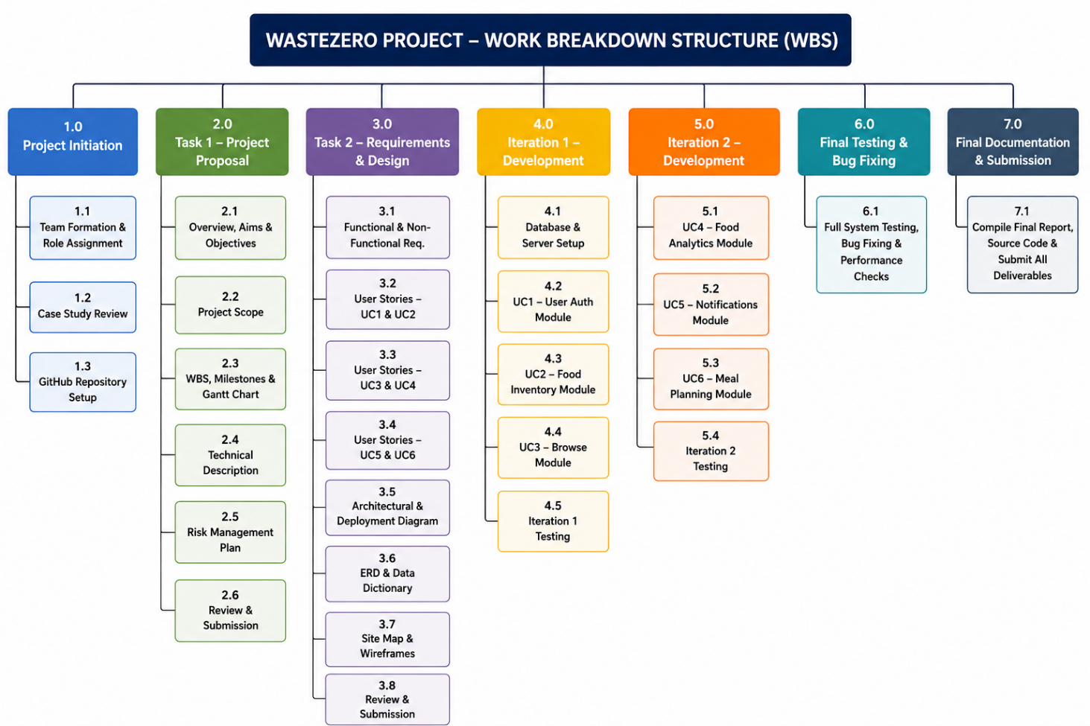

Summary:
S.N | Tasks | Description | Assigned to | Duration
1.0 | Project Initiation | Team setup and initial planning activities | All Members | 3 days
1.1 | Team Formation & Role Assignment | Assign team leader, members, and individual responsibilities. | All Members | 1 day
1.2 | Case Study Review | Read and analyze the SavePlate case study and use case diagram. | All Members | 1 day
1.3 | GitHub Repository Setup | Create team GitHub repo and define branch naming conventions. | Anurodh | 1 day
2.0 | Task 1 – Project Proposal | Write and submit the full project proposal document. | All Members | 25 days
2.1 | Overview, Aims & Objectives | Write Sections 1, 2, and 3 of the proposal. | All Members | 3 days
2.2 | Project Scope | Define in-scope and out-of-scope features based on the 6 use cases. | All Members | 2 days
2.3 | WBS, Milestones & Gantt Chart | Create WBS table, milestone list, and Gantt chart using GanttProject. | Nabin | 3 days
2.4 | Technical Description | Complete development and demonstration platform tables. | Anurodh | 2 days
2.5 | Risk Management Plan | Identify risks, assess probability, and define mitigations. | All Members | 2 days
2.6 | Review & Submission | Proofread final document and submit via HLMS by 12 June 2026. | All Members | 1 day
3.0 | Task 2: Requirements & Design | Write and submit requirements specification and design document. | All Members | 13 days
3.1 | Functional & Non-Functional Req. | Document all system requirements derived from the 6 use cases. | All Members | 3 days
3.2 | User Stories: UC1 & UC2 | Epics, user stories, acceptance criteria, MoSCoW, and tasks. | Anurodh | 3 days
3.3 | User Stories: UC3 & UC4 | Epics, user stories, acceptance criteria, MoSCoW, and tasks. | Nabin | 3 days
3.4 | User Stories: UC5 & UC6 | Epics, user stories, acceptance criteria, MoSCoW, and tasks. | Dipti | 3 days
3.5 | Architectural & Deployment Diagram | Create system architecture diagram using draw.io. | All Members | 1 day
3.6 | ERD & Data Dictionary | Design conceptual ERD and document all database tables and fields. | Nabin | 2 days
3.7 | Site Map & Wireframes | Design screen hierarchy and UI wireframes using Figma. | Dipti | 2 days
3.8 | Review & Submission | Proofread and submit via HLMS by 26 June 2026. | All Members | 1 day
4.0 | Iteration 1 Development | Implement UC1 (Register), UC2 (Inventory), UC3 (Browse). | All Members | 14 days
4.1 | Database & Server Setup | Set up XAMPP, MySQL schema, and project folder structure. | Nabin | 2 days
4.2 | UC1: User Auth Module | Register, login, email verification, 2FA, privacy settings. | Anurodh | 5 days
4.3 | UC2: Food Inventory Module | Add, edit, delete, mark as used, convert to donation. | Nabin | 5 days
4.4 | UC3: Browse Module | Browse, filter, claim donations, view item details. | Dipti | 4 days
4.5 | Iteration 1 Testing | Unit and integration testing of UC1, UC2, UC3. | All Members | 3 days
5.0 | Iteration 2Development | Implement UC4 (Analytics), UC5 (Notifications), UC6 (Meal Plan). | All Members | 14 days
5.1 | UC4: Food Analytics Module | Visual dashboard: food saved chart, donation chart, filters. | Anurodh | 5 days
5.2 | UC5: Notifications Module | Expiry alerts, donation updates, meal reminders (in-app + email). | Nabin | 5 days
5.3 | UC6: Meal Planning Module | Weekly calendar, recipe suggestions, inventory reservation. | Dipti | 5 days
5.4 | Iteration 2 Testing | Unit and integration testing of UC4, UC5, UC6. | All Members | 3 days
6.0 | Final Testing & Bug Fixing | Full system testing, bug resolution, and performance checks. | All Members | 7 days
7.0 | Final Documentation & Submission | Compile final report, source code, and submit all deliverables. | All Members | 5 days

5.1 Milestones and Deliverables
ID | Milestone | Deliverables | Date | Responsible
M1 | Project initialization  And started task one. | Team formed, GitHub repo created, case study reviewed | 22 May 2026 | All Members
M2 | Task 1 Submitted | Project Proposal / Project Plan document (this document) | 12 Jun 2026 | All Members
M3 | Task 2 Submitted | Requirements Specification and Design document | 26 Jun 2026 | All Members
M4 | Iteration 1 Complete | UC1 (Register), UC2 (Inventory), UC3 (Browse) developed and tested | 10 Jul 2026 | All Members
M5 | Iteration 2 Complete | UC4 (Analytics), UC5 (Notifications), UC6 (Meal Planning) developed and tested | 24 Jul 2026 | All Members
M6 | System Testing Complete | Full integration test report and bug fix log | 31 Jul 2026 | All Members
M7 | Final Submission | Complete project documentation, source code, and demo-ready system | 7 Aug 2026 | All Members

5.2 Gantt Chart
This Gantt chart was created using GanttProject. This Gantt chart shows our full procedure of design and development. The figure below shows the Gantt chart and resource allocation of our project.
Task 1:
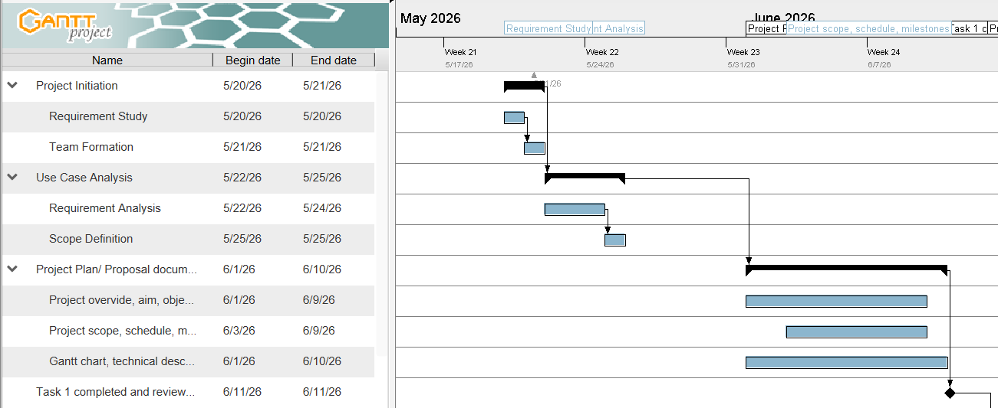
Task 2:
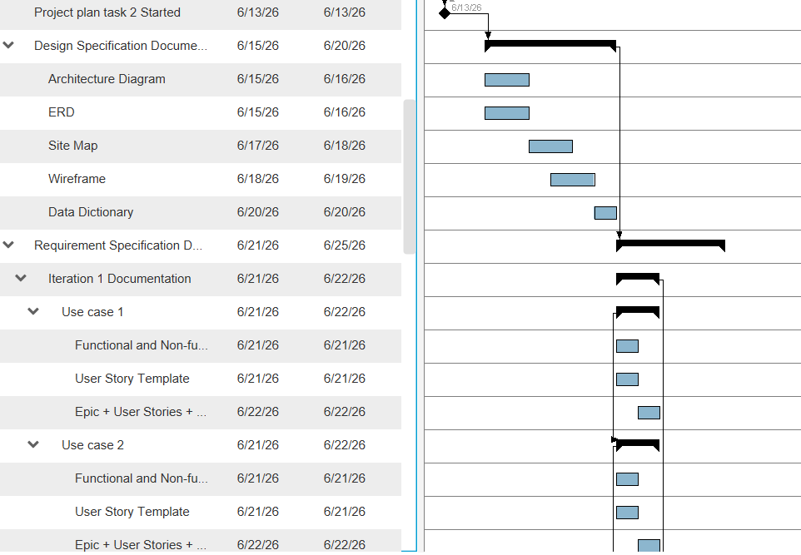
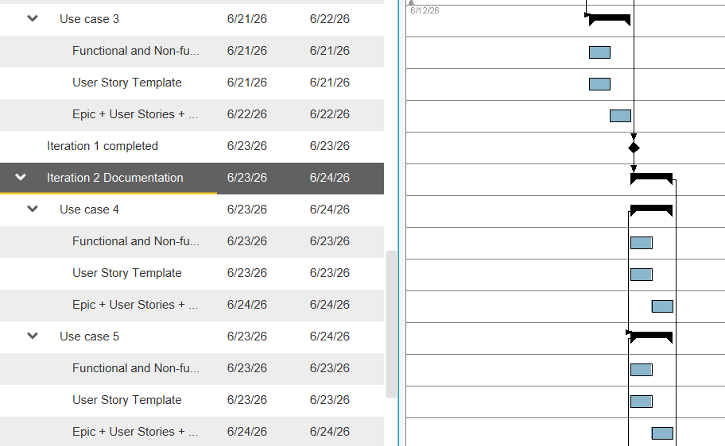
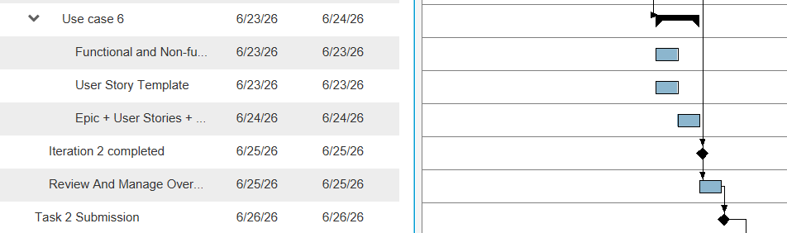
Assignment 2:
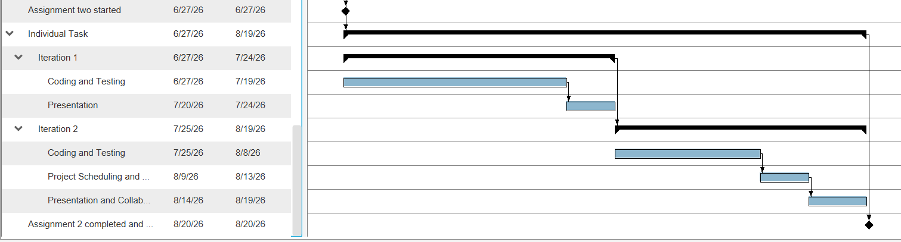

Resource allocation:
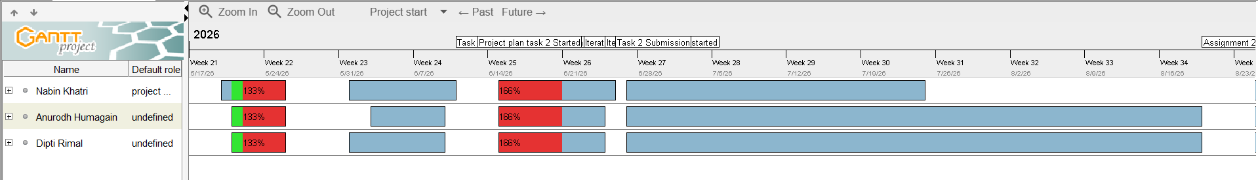

6. Technical description of the proposed system

Development Platform

Criteria | Tools/Hardware | Version | Description
Documentation | Microsoft Word | 2021/365 | We used Microsoft word for project reports, project documentation, requirement specification and analysis, design documentation.
Modeling  - Requirement  - Design | Draw.io  Draw.io  Figma.com | Latest | We use Draw.io to create use case diagram and requirement modeling.  We also used Draw.io to create ERD, Architecture Diagram, Site Map and UML diagram.  We used figma.com to wireframe, Prototype design.
Project Management | GanttProject | 3.x | We use GanttProject to create WBS, Milestones, Resource Allocation, and Gantt charts.
Collaboration | GitHub | Latest | It is used for source code management, and team collaboration works.
Framework  - Frond End  - Backend  - Database  - Local Server | HTML5, CSS3, JavaScript  Next.js  MySQL  XAMPP | Latest | They are used to develop the overall application’s user interface, client side functionalities.  It is used for server side processing and logics.  Used to store data of users, inventory, and other data.  It helps in maintaining development and testing environment.
Hardware (Notebook Spec) | Laptop | Hardware Spec : Ryzen 5, 16GB RAM.

Demonstration Platform

Criteria | Tools/Hardware | Version | Description
Browser | Google Chrome | Latest | It is used to run, test, debug and demonstrate the application.
Browser | Microsoft Edge | Latest | Used for compatibility testing of the application.
Operating System | Windows 11 | Latest | Development and Demonstration of the application.

7. Risk management plan
Risk Name | Absence of team member
Description | Due to personal issues and health issue, A member may be unavailable some days.
Probability (L/M/H) | M
Mitigation | Regular up date documents and share work milestone and knowledge among co-workers, maintaining every thing updated.

Risk Name | Schedule Delay
Description | Sometimes tasks may take longer than we planned.
Probability (L/M/H) | H
Mitigation | To avoid this, we can trace progress reports weekly and check milestones.

Risk Name | GitHub Collaboration Issues
Description | Code overwrite issue and fail to sync changes
Probability (L/M/H) | M
Mitigation | Prioritize using branches and pull requests and also regular commits.

Risk Name | Technical Skills Gap
Description | Members may struggle with XAMPP, GIT, MySQL, PHO, JavaScript.
Probability (L/M/H) | M
Mitigation | Learning materials and tutorials will be provided.

Risk Name | Data Loss
Description | Accidentally some code and part of code also document can be deleted.
Probability (L/M/H) | L
Mitigation | Prioritize GitHub updates and regular backups.

Risk Name | Requirement Changes
Description | During the development process some new features and requirements may be added.
Probability (L/M/H) | M
Mitigation | Analyze the requirement, set its priority, gather requirements and document changes after approval.

Risk Name | Testing Defects
Description | In some cases, major bugs can be discovered, this may take time to solve.
Probability (L/M/H) | M
Mitigation | Regular testing in each iteration and analyzing the possible issues.

Risk Name | Internet/Hardware Failure
Description | Serious physical damage on laptop or internet issues can interrupt work.
Probability (L/M/H) | L
Mitigation | Use of backup file in cloud or storing in other team member laptop and use of GIT Hub and use alternative device.

References

Programme, U. N. (2024). Food Waste Index Report 2024: Think Eat Save – Tracking Progress to Halve Global Food Waste. United Nations Environment Programme (or UNEP).https://www.unep.org/resources/publication/food-waste-index-report-2024

Appendix B: Marking Scheme
Student 1 | Anurodh Humagain
Student 2 | Dipti Rimal
Student 3 | Nabin Khatri
LO | Assessment Area | Marks | Poor | Satisfactory | Good | Excellent |  | Marks
CLO2 | Appropriate level of scope coverage  [17]
 | Title | 1
 | Overview | 4
 | Project Aims | 4
 | Project Objectives | 4
 | Project Scope | 4
CLO2 | Project plan [15]
 | Work breakdown | 5
 | Milestones/Deliverables | 5
 | Gantt chart - Timelines, Predecessors, Resource Usage, milestones | 5
CLO2 | Resource planning [8]
 | Development  Hardware/Software | 4
 | Demo Environment Hardware/Software | 2
CLO2 | Risk Management [4] | 2
CLO3 | Documentation[10]
 | Format Consistency | 10
 | Spelling/Grammar
 | Professionalism
 | TOTAL | 50 | SubTotal  ( /50) |  |  |  |  | 0
B. Requirements
CLO2 | Requirements definition [5]
 | Functional Requirements | 3
 | Non-functional Requirements | 2
CLO2 | Requirements specification [20] |  |  |  |  |  | Student 1 |  | Student 2 | Student 3
 | [1 + 2 + 4 + 3 = 10]  Epic + User Stories + AC+ Tasks | 10
 | [1 + 2 + 4 + 3 = 10]  Epic + User Stories + AC+ Tasks | 10
C. Design | Design [15]
CLO2 | Architectural Design | 2
 | Site Map | 2
 | Data Design[2]  Database/File Design[3] | 5
 | Wire frames [6] | 6
CLO3 | Documentation [10]
 | Format Consistency | 10
 | Spelling/Grammar
 | Professionalism
 | TOTAL | 50 |  |  |  | Sub-total  (/50 marks) | 0 |  | 0 | 0
 |  |  |  |  |  |  | Student 1 |  | Student 2 | Student 3
Violation of Academic Integrity Penalty
Late Submission | 5 marks per day ( ____ days)
 |  |  |  |  |  | TOTAL | 0 |  | 0 | 0

